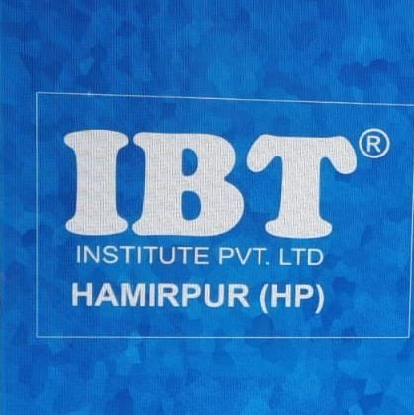 IBT(HAMIRPUR)HIM ACADEMY
WEEKLY SCHEDULE (HP GOVT. JOBS BATCH)
17-APRIL-2023 TO 22-April-2023
TIME/ DAYS | 9:30am –  10:30am | 10:30am -  11:30am | 11:30am –  12:30pm | 12:30pm – 1:30 pm | 1:30 pm-  2:00pm | 2:00pm – 3:00pm | 3:00 PM – 6:00PM
MON | English  (Article)  MS. KIRAN | Reasoning  (Alphabet test and number test)  MR. KAMAL | QUANT. (Quadratic equation)  MR. SHUBHAM | G.K  (Current Affair)  MS. REKHA | DAILY TEST | H.P G. K (MS.  REKHA) | DOUBT SESSION
TUE. | English  (Article)  MS. KIRAN | Reasoning  (Alphabet test and number test)  MR. KAMAL | QUANT.  (Quadratic equation)  MR. SHUBHAM | G.K  (Current Affair)  MS. REKHA | DAILY TEST | H.P G. K  (MS. REKHA) | DOUBT SESSION
WED. | English  (Article)  MS. KIRAN | Reasoning  (Coding decoding)  MR. KAMAL | QUANT.  (Ratio and proportion)  MR. SHUBHAM | G.K  (Religious movement)  MS. REKHA | DAILY TEST | H.P G. K  (MS. REKHA) | DOUBT SESSION
THU. | H.P G.K  (h.p economy)  MS. KIRAN | Reasoning  (Coding decoding)  MR. KAMAL | QUANT.  (Ratio and proportion)  MR. SHUBHAM | G.K  (Vedic Civilization )  MS. REKHA | DAILY TEST | H.P G. K  (MS. REKHA) | DOUBT SESSION
FRI. | H.P G.K (h.p economy)  MS. KIRAN | Hindi  (MR. KAMAL) | General science (MR.  SHUBHAM) | G.K  (Vedic civilization)  MS. REKHA | DAILY TEST | H.P G. K  (MS. REKHA) | DOUBT SESSION
SAT. | H.P G.K  (h.p economy)  MS. KIRAN | Hindi  (MR. KAMAL) | General Computer (MR. SHUBHAM) | G.K (Sangam age)  MS. REKHA | DAILY TEST | H.P G. K  (MS. REKHA | DOUBT SESSION

